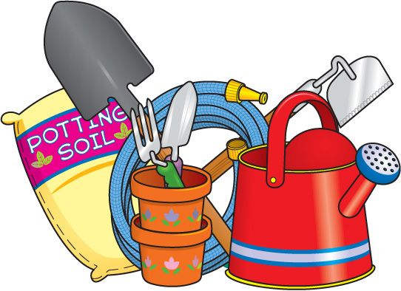



Annual Flower & Produce Show
Schedule

A display of own grown produce with competitive classes

Saturday 27th June 2026
Old Felixstowe Community Centre

Entrants set up 8:00am to 10:00am

Doors open for refreshments and plant sales from 10:30am

Open to view exhibits 11.30am to 4:00pm

FREE ENTRY

REFRESHMENTS, PLANT SALE, GRAND RAFFLE

All classes are competitive unless otherwise stated DISPLAY ONLY.
All exhibits must be own grown/produced unless otherwise stated.
You may enter each class twice and enter multiple classes, for judging purposes.

VEGETABLES (plates provided)
V1 | Selection of home-grown vegetables in own seed tray
V2 | Selection of home-grown salad crops in own seed tray
V3 | Three tomatoes, any variety
V4 | Five broad beans in pods
V5 | Five potatoes, any variety
V6 | Five peas in pods
V7 | 3/5 stems of chard, any variety
V8 | Five carrots
V9 | Three beetroots
V10 | 5/7 spring onions displayed in own tray
V11 | Two lettuces, any variety
V12 | An arrangement of herbs in a jam jar, may have flowers showing
V13 | Three sticks rhubarb
V14 | Any other vegetable (display only)

FRUIT (plates provided)
F1 | 5/7 Strawberries
F2 | Six gooseberries (may be unripe)
F3 | Three strigs of currants (any colour)
F4 | 5/7 Cherries
F5 | Any other fruit  SHOWSTOPPER VASE  A vase (provided or use own) of mixed flowering competitive stems containing a total of between five and ten stems taken from a minimum of two kinds of plants.  Arranged for frontal effect.

CUT FLOWERS (vase provided or use own)

CF1 | One vase sweet peas, up to seven stems
CF2 | One vase foliage (quality and quantity judged)
CF3 | One vase of one variety of perennials, up to five stems
CF4 | One vase of mixed annuals (grown from seed, up to five stems)
CF5 | One vase of Peonies 3/5 stems
CF6 | One vase of Alstroemeria 3/5 stems
CF7 | One vase of any annuals or perennials, or a mixture of both,  up to seven stems

ROSES (vase provided or use own)

R1 | One specimen hybrid tea rose (single bloom on stem)
R2 | Up to three stems any variety e.g. climber, rambler or shrub
R3 | One stem floribunda (multi headed variety)
R4 | One rose bloom, floating in a container (provided)
R5 | One stem scented bloom(s), any variety

POT & CONTAINER PLANTS – INDOOR OR OUTDOOR (please bring own saucer/tray to sit pot on)

PC1 | One flowering fuchsia
PC2 | Ornamental foliage fuchsia
PC3 | An arrangement of one or more cactus/succulent
PC4 | Flowering pot plant (e.g. orchid, begonias)
PC5 | Pot/container of mixed planting
PC6 | Flower with it's own foliage in a frame. (Provided) (One entry per person)

FLORAL DECORATION.
FD1 | A country garden design in a basket (using home-grown garden flowers and foliage)
FD2 | An all-round hand tied home-grown foliage arrangement showing a mixture of textures, sizes and colours.
FD3 | "Anyone for tennis". Accessories allowed. (Shop bought or home-grown foliage and flowers).
FD4 | A soft and romantic arrangement suitable for a wedding table. (Shop bought or home-grown foliage and flowers).
FD5 | A miniature arrangement in a mini jam jar. (Shop bought or home-grown foliage and flowers). Max height 6inches/15 cm)

PHOTOGRAPHY - winner selected by public vote.

P1 | June Rose
P2 | Lights, Camera, Action!
P3 | A splash of colour

HOME BAKING (plates provided, if required) Use own recipes

H1 | Mixed fruit loaf cake
H2 | Five strawberry tarts
H3 | Six savoury scones
H4 | Decorated carrot cake
H5 | A jar of strawberry jam
H6 | A jar of marmalade
H7 | A jar of fruit jelly
H8 | Five vegan chocolate cookies

Members relatives under 16 CLASS
Best in Class rosette awarded for First, Second and Third prize.

C1 | A mini beast using recycled materials e.g. wool, buttons, egg cartons etc
C2 | Mr Potato Head
C3 | Model using flower pots and a tennis ball.

